# QeeaHuuo

# Electronic Piano Diy Electronics Kit

# Installation Instructions

[1. Summary 2](#_Toc12934)

[2. Packing List 3](#_Toc25188)

[3. Circuit Board & Schematic Diagram 5](#_Toc4263)

[4. Welding Tutorials 8](#_Toc23480)

[5. Speaker Shell and Wiring Tutorial 14](#_Toc2730)

[6. Open source code 21](#_Toc22611)

# 1. Summary

This is a open source DIY project containing a card electronic piano and a speaker, for making electronic pianos and speakers for simulating simple card electronic pianos which, when connected to the speaker, can play sounds with electronic sound characteristics.

The project soldering difficulty is low, even the beginner of soldering and Arduion can be soldered quickly, you can learn the basics of electronic components, soldering, Arduion through this project, it is very suitable for use as a learning.

We have written the Arduion programme for the ATMEGA328P-PU, which uses the chip to detect capacitance changes

and outputs note signals using standard piano notes defined in the pitches.h library. You can always modify the code to play more different notes. You can even play a complete piece of music through the code!

Before you start, please read carefully all the installation instructions we provide. Different notes are played by detecting capacitive signals that cause static electricity to affect the input. At some point, there will be a sustained output of note errors. At this point, you need to discharge the static to minimise its effect on your project.

Please note that during installation, lay out all the components somewhere so that you can find them easily.

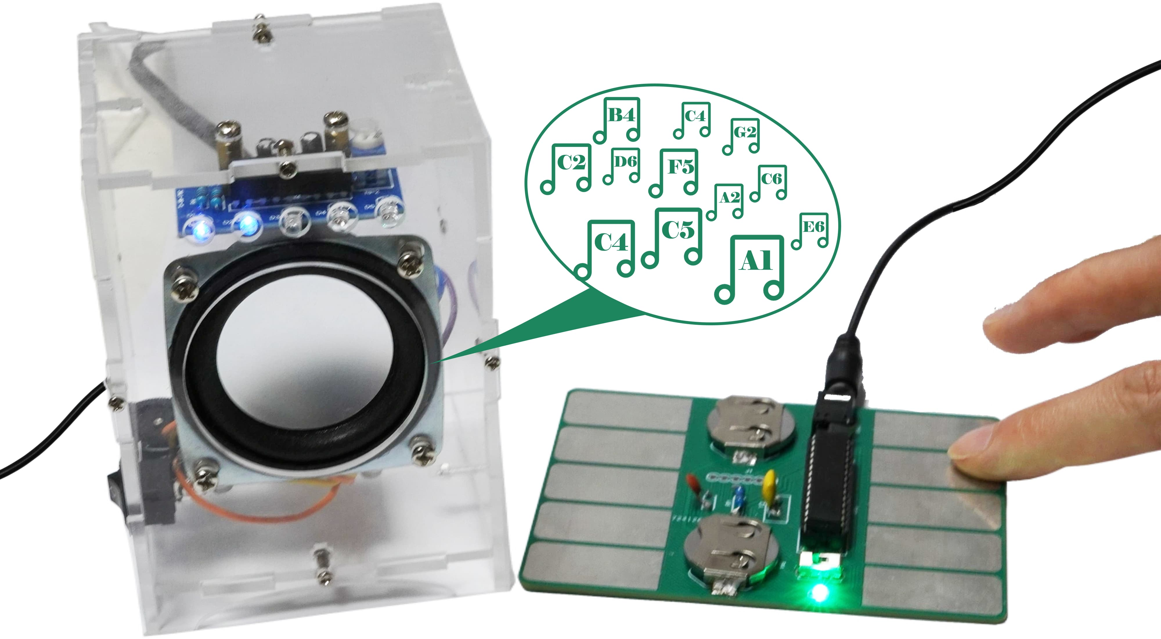

# Packing List

|  |  |  |  |  |  |  |  |
| --- | --- | --- | --- | --- | --- | --- | --- |
| **B-6** | **LED DIP** | **5PCS** | **IMG_256** | **C-42** | **Metal film Resistor 10KR** | **2PCS** | **IMG_257** |
| **B-12** | **Electrolytic Capacitor 10UF** | **3PCS** | **IMG_258** | **C-46** | **Metal film Resistor 22KR** | **1PC** | **IMG_259** |
| **B-17** | **Ceramic Capacitor 104UF** | **2PCS** | **IMG_260** | **B-117** | **Board Package** | **3PCS** |  |
| **B-120** | **Electrolytic Capacitor 470UF** | **1PC** | **IMG_261** | **B-125** | **Speaker Source Wire** | **1PC** | IMG_262 |
| **B-110** | **ATMEGA328P-PU&DIP 28 Socket** | **1PC** | **IMG_263** | **B-126** | **Speaker Shell** | **6PCS** | IMG_264 |
| **B-113** | **SMD LED Green** | **1PC** |  | **B-127** | **Speaker Wires** | **1PC** | IMG_265 |
| **B-114** | **Crystal oscillator ZTT16.0MX** | **1PC** | **IMG_266** | **B-128** | **Speaker Stud** | **4PCS** | IMG_267 |
| **B-119** | **Ceramic Capacitor 1UF** | **1PC** | **IMG_268** | **B-129** | **Speaker Screw** | **4PCS** | IMG_269 |
| **B-122** | **Audio power amplifier 8002B** | **1PC** | **IMG_270** | **B-130** | **Speaker Shell Screw** | **12PCS** | IMG_271 |
| **B-123** | **Potentiometer 10K** | **1PC** | **IMG_272** | **B-115** | **Switch DIP3** | **1PC** | **IMG_273** |
| **B-124** | **Detection amplifier** | **1PC** | **IMG_274** | **B-116** | **CR2032 batterie Socket** | **2PCS** | **IMG_275** |
| **B-131** | **Potentiometer (Round, Black)** | **1PC** | **IMG_276** | **B-112** | **Earphone Socket** | **1PC** | **IMG_277** |
| **C-21** | **Metal film Resistor 10R** | **1PC** | **IMG_278** | **B-121** | **Boat Switch** | **1PC** | **IMG_279** |
| **C-35** | **Metal film Resistor 1KR** | **1PC** | **IMG_280** | **B-122** | **Button Coin Battery** | **2PCS** | **IMG_281** |

# Circuit Board & Schematic Diagram

## 3.1 Board-C:Electronic Piano Board

|  |  |
| --- | --- |
| 电路1 (自定义) | 图片6 |

## 3.2 Board-A:Speaker Main Board

|  |  |
| --- | --- |
| 图片1 | 图片2 |

## 3.3 Board-B:Speaker Led Board

|  |  |
| --- | --- |
| 图片4 | 图片5 |

# 4. Welding Tutorials

## 4.1 Board-C

This is the core board of the electronic piano, please solder it according to the example drawing below.Please place the board in the direction of the picture.

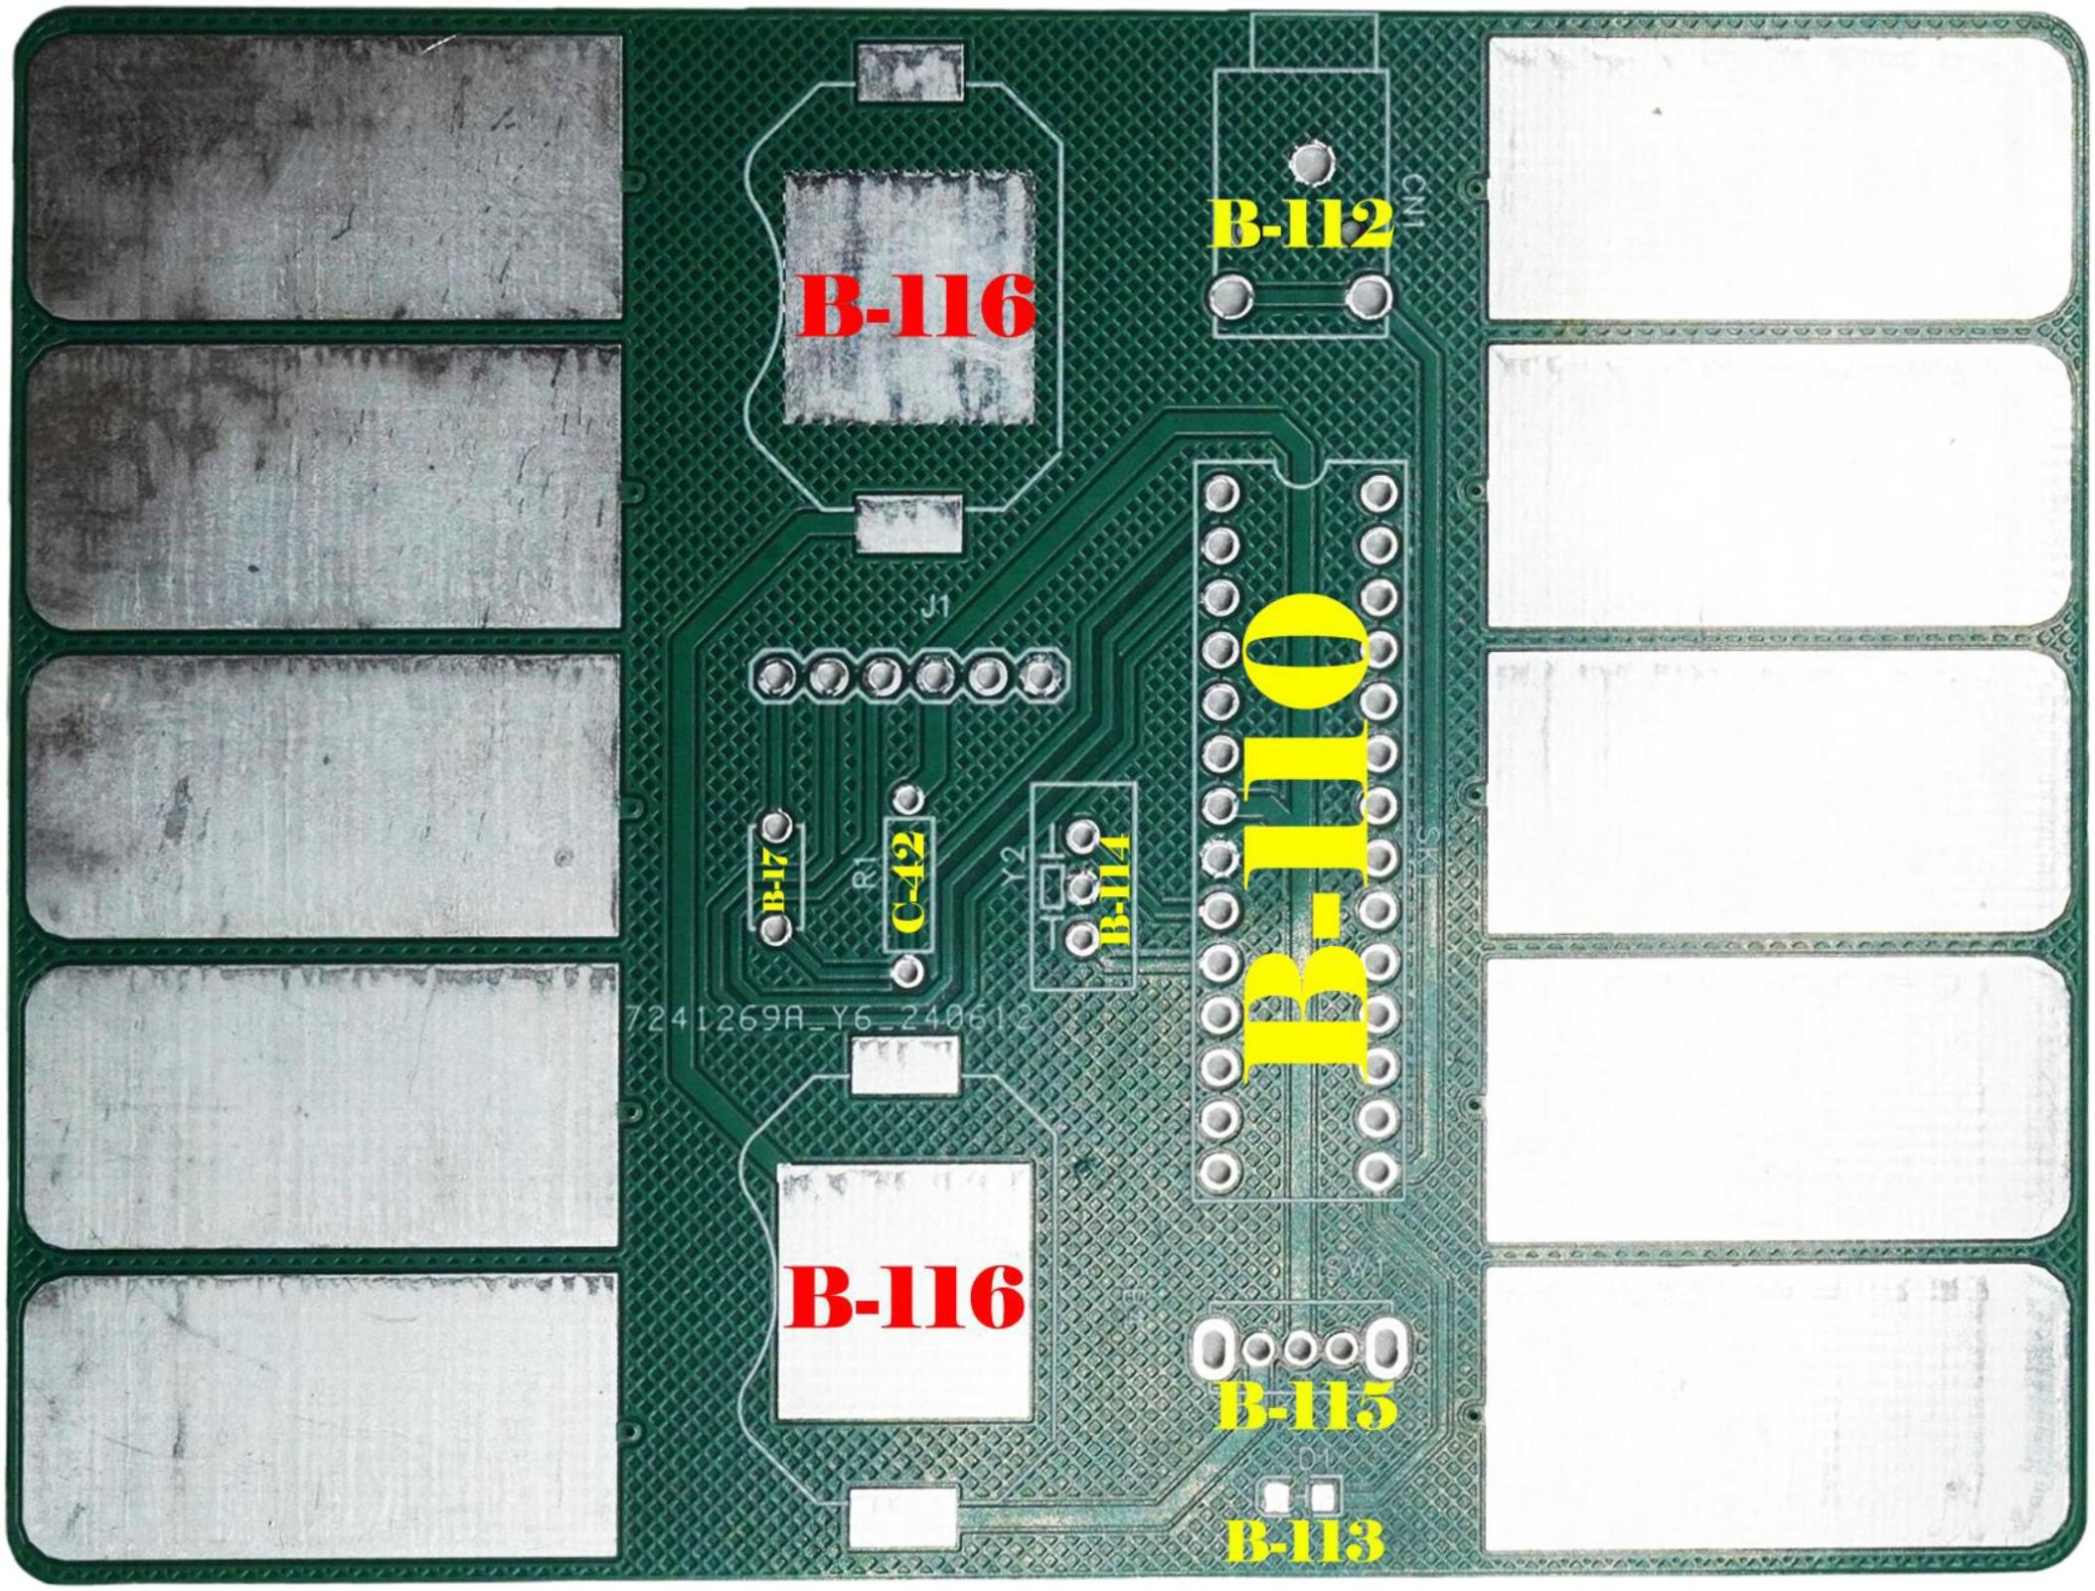

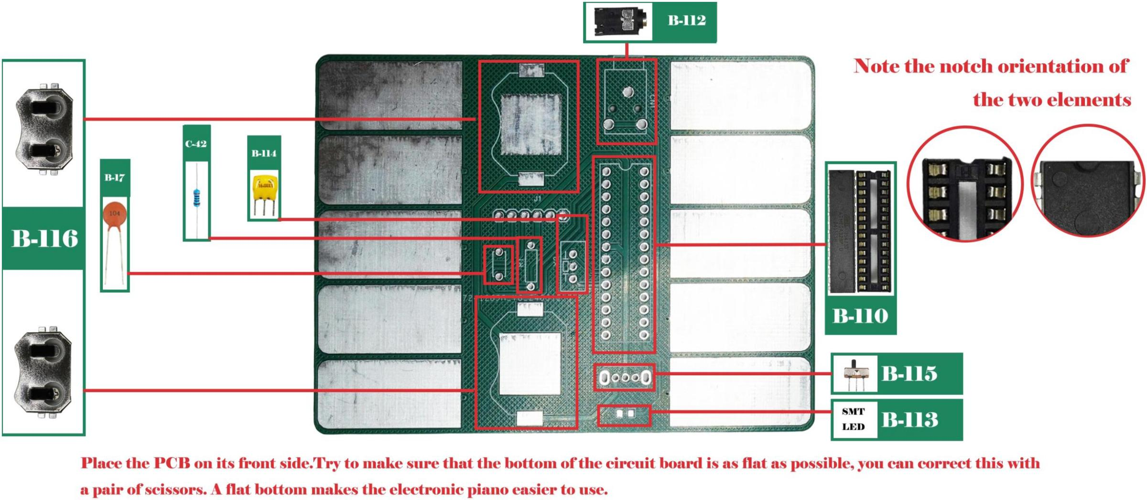

Please note:

1. When soldering B-110 components, you must solder the socket before inserting the ATMEGA328P-PU into the socket.Be sure to observe the orientation of the socket and the ATMEGA328P-PU.

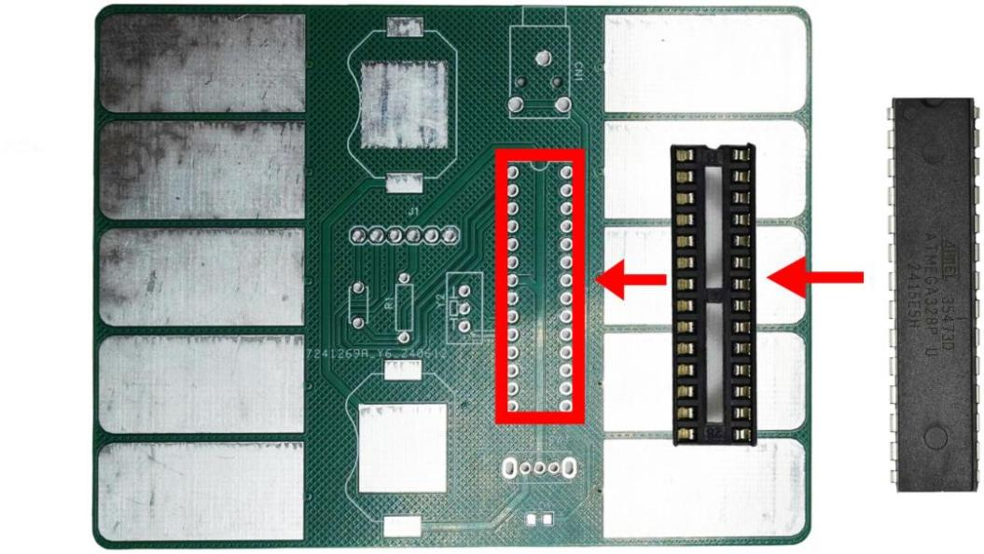 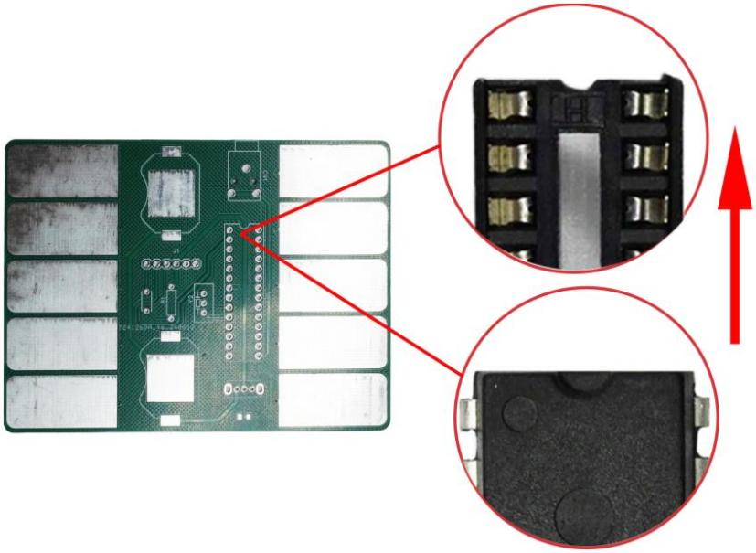

2. When soldering other boards, we will also use C-42 and B-17 components, so do not discard them after soldering.

3. When soldering LEDs, there is no need to distinguish between positive and negative poles, but be careful because the LEDs are so small. If you accidentally lose them, you can find replacements in the bag numbered B-113.

## 4.2 Board-A&Board-B

## We are going to explain how to solder both the front side of board A and the back side of board A, board B. Use the table below to find the appropriate components and PCB markings.

|  |  |  |  |  |
| --- | --- | --- | --- | --- |
| **Component No.** | **Component Name** | **Front A** | **BACK A** | **B** |
| **B-119** | **Ceramic Capacitor 1UF** | **C1** |  |  |
| **B-17** | **Ceramic Capacitor 104UF** | **C2** |  |  |
| **B-120** | **Electrolytic Capacitor 470UF** | **C4** |  |  |
| **C-21** | **Metal film Resistor 10R** | **R1** |  |  |
| **C-46** | **Metal film Resistor 22KR** | **R2** |  |  |
| **C-35** | **Metal film Resistor 1KR** |  |  | **R3** |
| **B-131** | **Potentiometer (Round, Black)** | **RP1** |  |  |
| **B-122** | **Audio power amplifier 8002B** |  | **U1** |  |
| **B-12** | **Electrolytic Capacitor 10UF** | **C3** |  | **C5 C6** |
| **B-123** | **Potentiometer 10K** |  |  | **RP2** |
| **B-124** | **Detection amplifier** |  |  | **U2** |
| **B-6** | **LED DIP** |  |  | **D1~D5** |

Before you start, you need to know the positive and negative terminals of the capacitors and LEDs. This is shownin the diagram below:Where the white part indicates the negative terminal and the black part indicates the positive terminal.The symbols for LEDs are as follows:

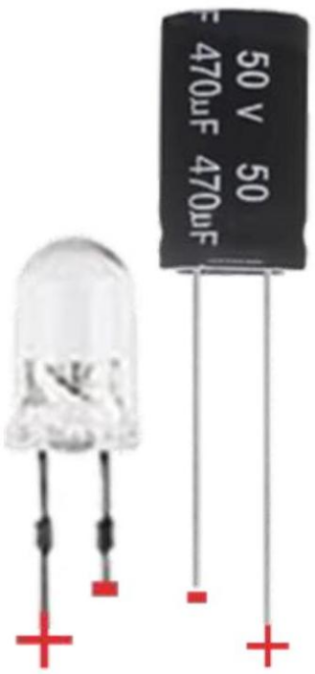

When soldering the backside of board A, be sure to note the orientation of B-122 (8002B); there is a small dot

on 8002B used to indicate the orientation:

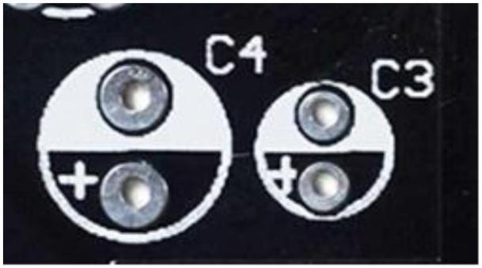

Where the white part indicates the negative terminal and the black part indicates the positive terminal.The symbols for LEDs are as follows:

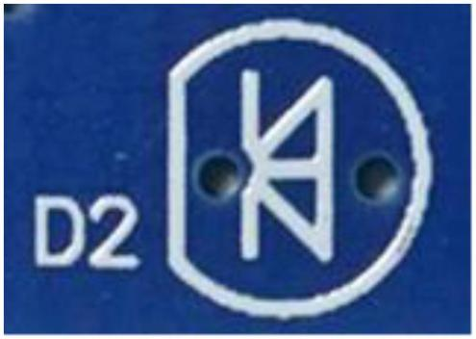

Negative on the left, positive on the right

When soldering the backside of board A, be sure to note the orientation of B-122 (8002B); there is a small dot on 8002B used to indicate the orientation:

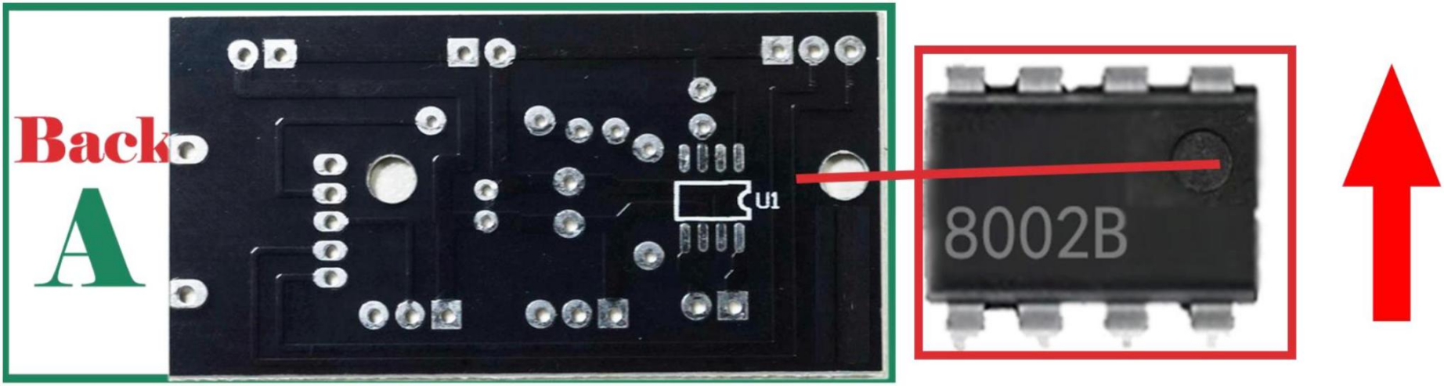

When soldering board B, the B-124 component (Detection amplifier) needs to be soldered to this position, while noting that the component has the direction of the word corresponding to the PCB：

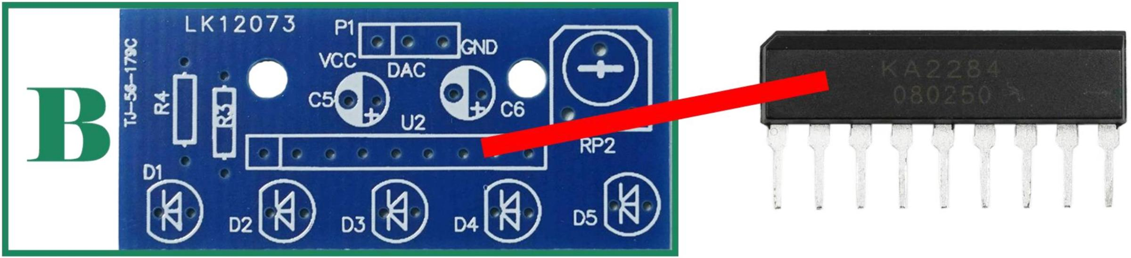

# 5. Speaker Shell and Wiring Tutorial

## 5.1 Shell No.

We have 6 enclosures to install, first let's set a unique number for each one so we can distinguish them:

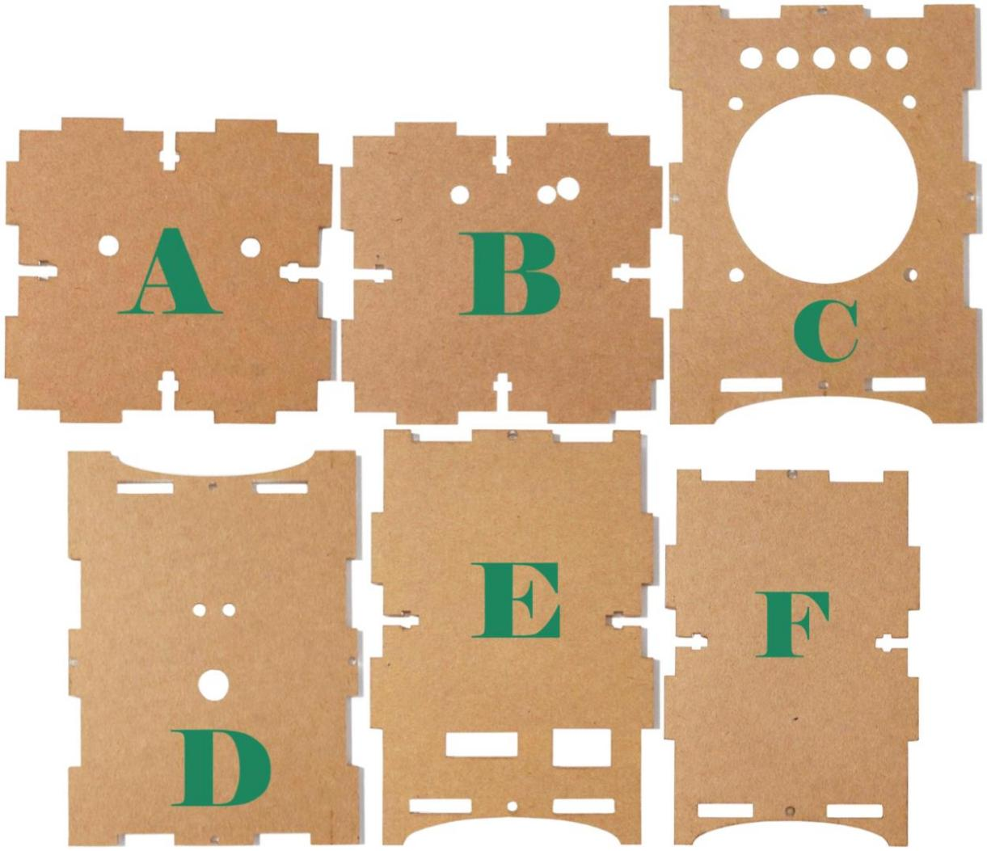

You can remove the probefore tective film from the housing starting the installation. Please note: The case is made of acrylic, a material that is prone to scratching and cracking, so please do not place it on sharp objects.

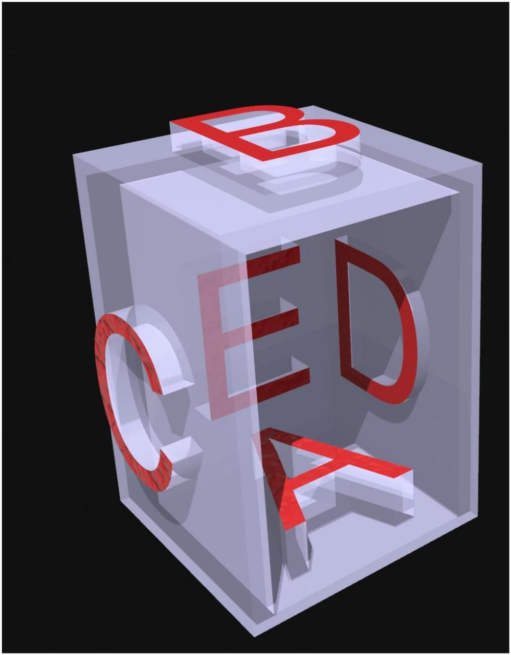

This diagram briefly illustrates the mounting positions of the 6 boards

## 5.2 Installation of wires to the shell D\E

## Install the input wires and switch according to the diagram below:

## 图片19图片20

## 5.3 Know ahead of time what the other shells will do

Knowing in advance what the other enclosures are doing can help you use the right length of wire when connecting components with wires.Please note that you only need to know what each enclosure does before connecting all the wires without installing them.

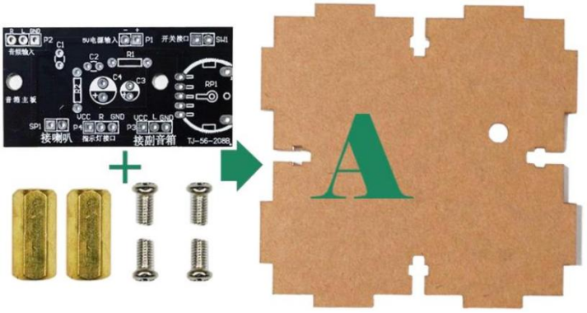 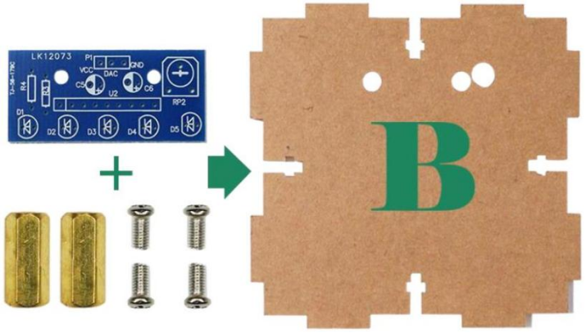

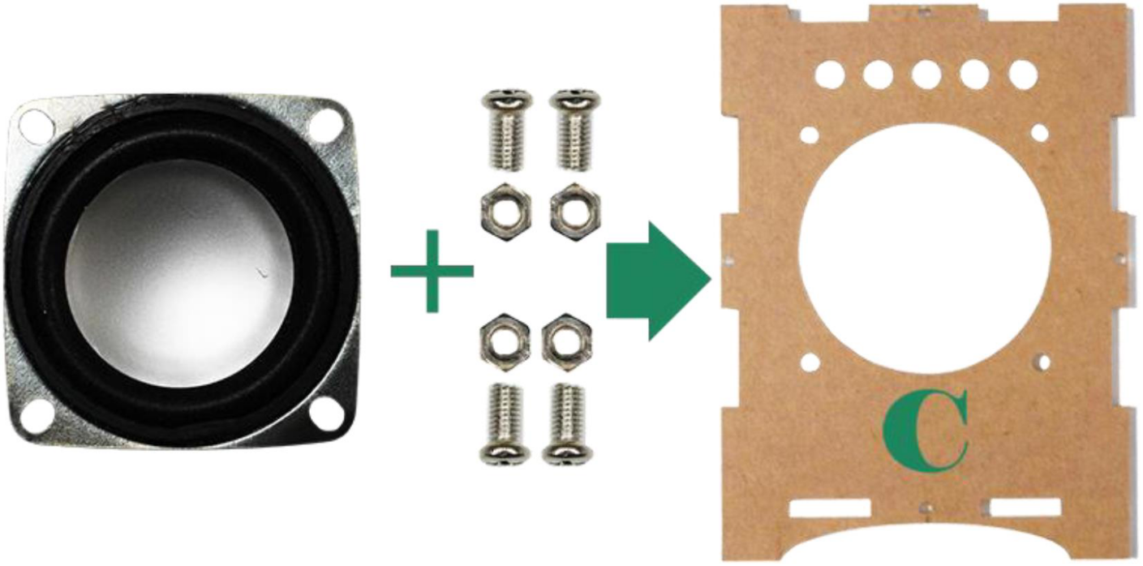

From the diagram above, you can see that Board A needs to be mounted on Cabinet A, Board B on Cabinet B and the speaker on Cabinet C.

## 5.4 Connecting the input cable and board A\B

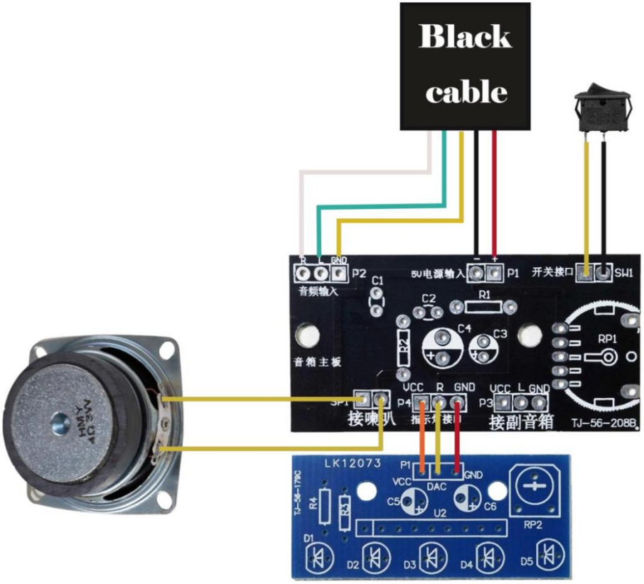

**Please note**

1. Each wire is coated with tin, so soldering with a soldering iron is a very good option.

2. The black wire in the picture above is the input wire you have just installed. It has 5 different coloured wires, please connect them according to the corresponding colours.

3. In addition to the input wire, there are 7 more wires to connect. However, you will notice that there is only one set of 5 wires in the box, so you will need to cut two of them by hand. This is to save space inside the speaker. When cutting the wires, make sure that you have the length of wire needed to connect Board A to Board B.

## 5.5 Mounting each component to the shell

Now we can fit all the components into the case. Simply install them as described above:

 



## 5.6 Combined shells

Now we need to use these screws to assemble the shells：

1. Install a screw into a hole in one of the housings like in the picture below:

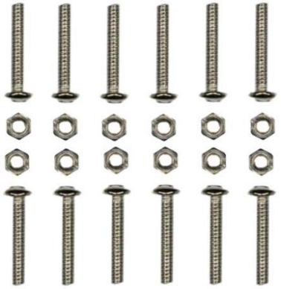

1. Place the nut into the slot in the other housing and you can adjust the distance of the nut to fit it：

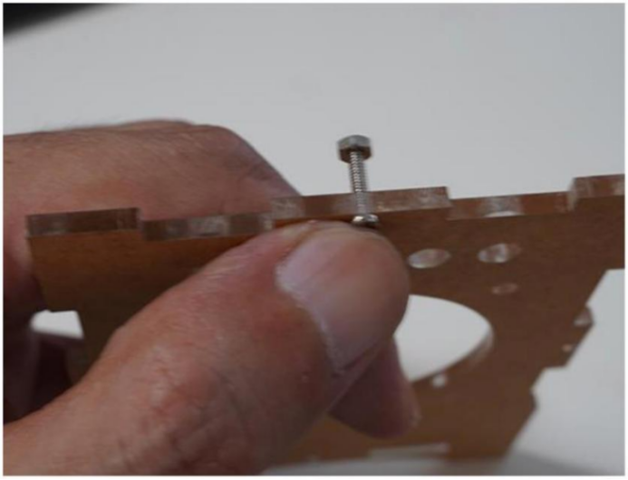 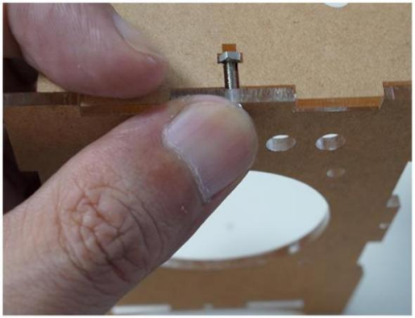

1. Use other tools to tighten the screws:

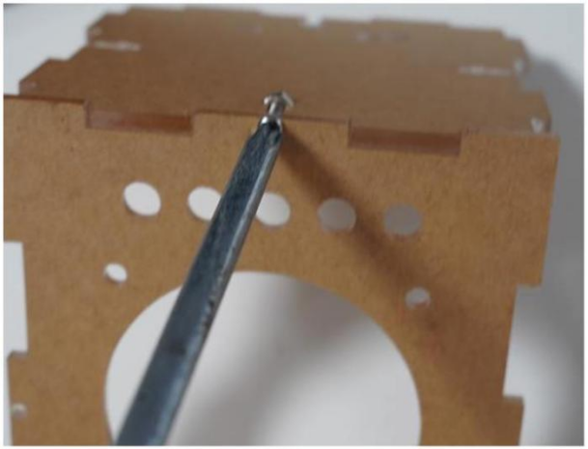

1. Assemble the other housings in the same way.

# Open source code

As mentioned at the beginning, this is an open source project, so if you own an arduion UNO R3, you can always modify the code of the ATMEGA328P-PU to design your own electronic music!

## 6.1 pitches.h

This project uses the pitches.h library to define notes:

#define NOTE\_B0 31

#define NOTE\_C1 33

#define NOTE\_CS1 35

#define NOTE\_D1 37

#define NOTE\_DS1 39

#define NOTE\_E1 41

#define NOTE\_F1 44

#define NOTE\_FS1 46

#define NOTE\_G1 49

#define NOTE\_GS1 52

#define NOTE\_A1 55

#define NOTE\_AS1 58

#define NOTE\_B1 62

#define NOTE\_C2 65

#define NOTE\_CS2 69

#define NOTE\_D2 73

#define NOTE\_DS2 78

#define NOTE\_E2 82

#define NOTE\_F2 87

#define NOTE\_FS2 93

#define NOTE\_G2 98

#define NOTE\_GS2 104

#define NOTE\_A2 110

#define NOTE\_AS2 117

#define NOTE\_B2 123

#define NOTE\_C3 131

#define NOTE\_CS3 139

#define NOTE\_D3 147

#define NOTE\_DS3 156

#define NOTE\_E3 165

#define NOTE\_F3 175

#define NOTE\_FS3 185

#define NOTE\_G3 196

#define NOTE\_GS3 208

#define NOTE\_A3 220

#define NOTE\_AS3 233

#define NOTE\_B3 247

#define NOTE\_C4 262

#define NOTE\_CS4 277

#define NOTE\_D4 294

#define NOTE\_DS4 311

#define NOTE\_E4 330

#define NOTE\_F4 349

#define NOTE\_FS4 370

#define NOTE\_G4 392

#define NOTE\_GS4 415

#define NOTE\_A4 440

#define NOTE\_AS4 466

#define NOTE\_B4 494

#define NOTE\_C5 523

#define NOTE\_CS5 554

#define NOTE\_D5 587

#define NOTE\_DS5 622

#define NOTE\_E5 659

#define NOTE\_F5 698

#define NOTE\_FS5 740

#define NOTE\_G5 784

#define NOTE\_GS5 831

#define NOTE\_A5 880

#define NOTE\_AS5 932

#define NOTE\_B5 988

#define NOTE\_C6 1047

#define NOTE\_CS6 1109

#define NOTE\_D6 1175

#define NOTE\_DS6 1245

#define NOTE\_E6 1319

#define NOTE\_F6 1397

#define NOTE\_FS6 1480

#define NOTE\_G6 1568

#define NOTE\_GS6 1661

#define NOTE\_A6 1760

#define NOTE\_AS6 1865

#define NOTE\_B6 1976

#define NOTE\_C7 2093

#define NOTE\_CS7 2217

#define NOTE\_D7 2349

#define NOTE\_DS7 2489

#define NOTE\_E7 2637

#define NOTE\_F7 2794

#define NOTE\_FS7 2960

#define NOTE\_G7 3136

#define NOTE\_GS7 3322

#define NOTE\_A7 3520

#define NOTE\_AS7 3729

#define NOTE\_B7 3951

#define NOTE\_C8 4186

#define NOTE\_CS8 4435

#define NOTE\_D8 4699

#define NOTE\_DS8 4978

## 6.2 ATMEGA328P-PU

/\*

This project uses the basic pitch function to play notes.

In the main loop function below, we can choose the key behaviour you want by changing the unannotated function. You can also write your own if you understand basic programming!

The project uses the function tone to generate sounds, using the pitches.h library to define the frequencies of the different notes. The code also includes a function called readCapacitivePin that measures the capacitance on the pin.

\*/

#include "pitches.h"

int notelength = 20;//Note length

int outputpin = 9;//Audio Output Pins

int capacitance = 8;//Capacitance Measurement Pins pitches.h

void setup(void)

{

tone(outputpin, NOTE\_A4, 500); //Initialise the Arduino board and beep to indicate that the device is working.

}

/////////////////////////////////////////////////////////////////////////////////////

void loop(void)

{

aeoliancap();

}

/////////////////////////////////////////////////////////////////////////////////////

#include "pins\_arduino.h"

uint8\_t readCapacitivePin(int pinToMeasure) {

volatile uint8\_t\* port;

volatile uint8\_t\* ddr;

volatile uint8\_t\* pin;

byte bitmask;

port = portOutputRegister(digitalPinToPort(pinToMeasure));

ddr = portModeRegister(digitalPinToPort(pinToMeasure));

bitmask = digitalPinToBitMask(pinToMeasure);

pin = portInputRegister(digitalPinToPort(pinToMeasure));

\*port &= ~(bitmask);

\*ddr |= bitmask;

delay(1);

noInterrupts();

\*ddr &= ~(bitmask);

\*port |= bitmask;

uint8\_t cycles = 17;

if (\*pin & bitmask) { cycles = 0;}

else if (\*pin & bitmask) { cycles = 1;}

else if (\*pin & bitmask) { cycles = 2;}

else if (\*pin & bitmask) { cycles = 3;}

else if (\*pin & bitmask) { cycles = 4;}

else if (\*pin & bitmask) { cycles = 5;}

else if (\*pin & bitmask) { cycles = 6;}

else if (\*pin & bitmask) { cycles = 7;}

else if (\*pin & bitmask) { cycles = 8;}

else if (\*pin & bitmask) { cycles = 9;}

else if (\*pin & bitmask) { cycles = 10;}

else if (\*pin & bitmask) { cycles = 11;}

else if (\*pin & bitmask) { cycles = 12;}

else if (\*pin & bitmask) { cycles = 13;}

else if (\*pin & bitmask) { cycles = 14;}

else if (\*pin & bitmask) { cycles = 15;}

else if (\*pin & bitmask) { cycles = 16;}

interrupts();

\*port &= ~(bitmask);

\*ddr |= bitmask;

return cycles;

}

void aeoliancap(void)

{

if(readCapacitivePin(6) > capacitance) {tone(outputpin, NOTE\_A4, notelength);}

if(readCapacitivePin(5) > capacitance) {tone(outputpin, NOTE\_B4, notelength);}

if(readCapacitivePin(4) > capacitance) {tone(outputpin, NOTE\_C5, notelength);}

if(readCapacitivePin(3) > capacitance) {tone(outputpin, NOTE\_D5, notelength);}

if(readCapacitivePin(2) > capacitance) {tone(outputpin, NOTE\_E5, notelength);}

if(readCapacitivePin(7) > capacitance) {tone(outputpin, NOTE\_F5, notelength);}

if(readCapacitivePin(8) > capacitance) {tone(outputpin, NOTE\_G5, notelength);}

if(readCapacitivePin(10) > capacitance) {tone(outputpin, NOTE\_A5, notelength);}

if(readCapacitivePin(11) > capacitance) {tone(outputpin, NOTE\_B5, notelength);}

if(readCapacitivePin(12) > capacitance) {tone(outputpin, NOTE\_C6, notelength);}

}

void aeolianbt(void)

{

if(readCapacitivePin(6) > capacitance) {tone(outputpin, NOTE\_A1, notelength);}

if(readCapacitivePin(5) > capacitance) {tone(outputpin, NOTE\_C2, notelength);}

if(readCapacitivePin(4) > capacitance) {tone(outputpin, NOTE\_E2, notelength);}

if(readCapacitivePin(3) > capacitance) {tone(outputpin, NOTE\_G2, notelength);}

if(readCapacitivePin(2) > capacitance) {tone(outputpin, NOTE\_A2, notelength);}

if(readCapacitivePin(7) > capacitance) {tone(outputpin, NOTE\_A4, notelength);}

if(readCapacitivePin(8) > capacitance) {tone(outputpin, NOTE\_C5, notelength);}

if(readCapacitivePin(10) > capacitance) {tone(outputpin, NOTE\_E5, notelength);}

if(readCapacitivePin(11) > capacitance) {tone(outputpin, NOTE\_G5, notelength);}

if(readCapacitivePin(12) > capacitance) {tone(outputpin, NOTE\_A5, notelength);}

}

void pentatonic(void) {

if(readCapacitivePin(6) > capacitance) {amscale();}

if(readCapacitivePin(5) > capacitance) {dmscale();}

if(readCapacitivePin(4) > capacitance) {e7scale();}

if(readCapacitivePin(3) > capacitance) {fscale();}

if(readCapacitivePin(2) > capacitance) {gscale();}

}

void amscale(void) {

if(readCapacitivePin(7) > capacitance) {tone(outputpin, NOTE\_A4, notelength);}

if(readCapacitivePin(8) > capacitance) {tone(outputpin, NOTE\_C5, notelength);}

if(readCapacitivePin(10) > capacitance) {tone(outputpin, NOTE\_E5, notelength);}

if(readCapacitivePin(11) > capacitance) {tone(outputpin, NOTE\_G5, notelength);}

if(readCapacitivePin(12) > capacitance) {tone(outputpin, NOTE\_A5, notelength);}

}

void dmscale(void) {

if(readCapacitivePin(7) > capacitance) {tone(outputpin, NOTE\_D5, notelength);}

if(readCapacitivePin(8) > capacitance) {tone(outputpin, NOTE\_F5, notelength);}

if(readCapacitivePin(10) > capacitance) {tone(outputpin, NOTE\_A5, notelength);}

if(readCapacitivePin(11) > capacitance) {tone(outputpin, NOTE\_C6, notelength);}

if(readCapacitivePin(12) > capacitance) {tone(outputpin, NOTE\_D6, notelength);}

}

void e7scale(void) {

if(readCapacitivePin(7) > capacitance) {tone(outputpin, NOTE\_E5, notelength);}

if(readCapacitivePin(8) > capacitance) {tone(outputpin, NOTE\_GS5, notelength);}

if(readCapacitivePin(10) > capacitance) {tone(outputpin, NOTE\_B5, notelength);}

if(readCapacitivePin(11) > capacitance) {tone(outputpin, NOTE\_D6, notelength);}

if(readCapacitivePin(12) > capacitance) {tone(outputpin, NOTE\_E6, notelength);}

}

void cscale(void) {

if(readCapacitivePin(7) > capacitance) {tone(outputpin, NOTE\_C5, notelength);tone(outputpin, NOTE\_C5, notelength);tone(outputpin, NOTE\_C5, notelength);tone(outputpin, NOTE\_C5, notelength);}

if(readCapacitivePin(8) > capacitance) {tone(outputpin, NOTE\_E5, notelength);}

if(readCapacitivePin(10) > capacitance) {tone(outputpin, NOTE\_G5, notelength);}

if(readCapacitivePin(11) > capacitance) {tone(outputpin, NOTE\_B5, notelength);}

if(readCapacitivePin(12) > capacitance) {tone(outputpin, NOTE\_C6, notelength);}

}

void fscale(void) {

if(readCapacitivePin(7) > capacitance) {tone(outputpin, NOTE\_F5, notelength);}

if(readCapacitivePin(8) > capacitance) {tone(outputpin, NOTE\_A5, notelength);}

if(readCapacitivePin(10) > capacitance) {tone(outputpin, NOTE\_C6, notelength);}

if(readCapacitivePin(11) > capacitance) {tone(outputpin, NOTE\_E6, notelength);}

if(readCapacitivePin(12) > capacitance) {tone(outputpin, NOTE\_F6, notelength);}

}

void gscale(void) {

if(readCapacitivePin(7) > capacitance) {tone(outputpin, NOTE\_G5, notelength);}

if(readCapacitivePin(8) > capacitance) {tone(outputpin, NOTE\_B5, notelength);}

if(readCapacitivePin(10) > capacitance) {tone(outputpin, NOTE\_D6, notelength);}

if(readCapacitivePin(11) > capacitance) {tone(outputpin, NOTE\_F6, notelength);}

if(readCapacitivePin(12) > capacitance) {tone(outputpin, NOTE\_G6, notelength);}

}